Ear Wax  Ear wax is normal and is produced to form a protective coating over the skin in the ear canal. Ears are normally self-cleaning and wax will usually fall out without you noticing. Do not use a cotton wool bud to clean the ear as this will push the wax in further and can introduce infection.  Ear wax only becomes a problem if it causes deafness, discomfort or a health professional requires a clear view of your ear drum.  If you experience any of the following you should seek advice from your GP or Nurse Practitioner:  - Pain  - Discharge or bleeding from the ear  - Sudden deafness or buzzing  - Foreign bodies in the ear  - Dizziness | Ear Wax Removal  Olive Oil Drops to soften wax:  The following needs to be done 2-3 times daily for 14 days:  - Lie on your side with the affected ear uppermost  - Put a good teaspoon of olive oil into the affected ear  - Stay laying on your side to allow the wax to soak for around 10 minutes  - Afterwards do not plug your ear with cotton wool as this will simply absorb the oil  Your hearing may initially worsen after first starting to use olive oil drops so we advise you only treat one ear at a time.  In most cases after 14 days the wax will have softened sufficiently to encourage the wax to come out without further intervention. However if you wish you can use an ear bulb syringe after wax softening for 14 days. | Ear Bulb Syringing  There are now over the counter kits available from pharmacies. These usually contain a wax softener to use for 14 days firstly and a small bulb syringe to enable you to remove the wax gently from your ear canals yourself.  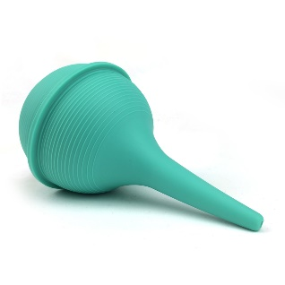  Do NOT use a bulb syringe if you:  - Have had complications following this procedure in the past.  - Currently have grommets in place.  - Have had ear surgery in the past.  - Have a cleft palate (even if it has been repaired).  - Have an ear infection or have had an ear infection in the previous six weeks.  - Have recurring infections of the ear canal (recurring otitis externa).  - Have, or have had, a burst (perforated) eardrum.

